Leshun Xinke LSP980 series landscape consumer machine
API Direction For Developer
（V1.01）

date changed | edition | Modify the description | author | remarks
2023-6-28 | V1.01 | first draft | Ljh

catalogue
1. Overview 4
2. Software interface 4
2.1 Overview 4
2.2 Screen backlight interface 5
2.3 Uart, read and write interface 5
2.4 Sweep the wharf interface 6
2.5 NFC interface 6
2.6 System information interface 10
2.7 Camera interface 11
2.8 Restart / timing restart 11
2.9 Printer interface 11
2.10 Hide the navigation bar and the status bar 12
2.11, silent installation 13
2.12, dual-screen display 13
3. Commissioning instructions 13
3.1 Install the APK 13
3.2 adb debugging 14

1. Overview

The landscape consumer machine equipment uses Qualcomm Snapdragon 8-core processor, supports various payment methods such as credit card swiping / code scanning / Brushing palms, and supports receipt printing, which can be widely used in scenic spot ticketing, office areas, hotels, office buildings, schools, shopping malls, canteens, retail and other scenarios. This document applies to the models:
LSP980- - - - -10-inch screen + 5-inch screen with printer (no camera)

2. Software interface

2.1 Overview

1) The hardware related interfaces of the device are encapsulated in the com.leshun.hwadapter.jar package provided with the documentation. You only need to add this jar package to the App's dependency library and import the relevant interface classes, as follows:
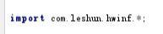
Note, do not confuse these interface classes, add the following (or similar) to the confusion rule:
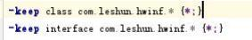
2) The following interface classes are enclosed in the package:
LedAdapter：LED interface, such as white light, infrared fill light, light belt, screen backlight, etc.
NFCAdapter：NFC class interface, package NFC read card and return data interface.
SerialPortAdapter：Serial port interface, which encapsulates the Uart port read and write interface.
SystemAdapter：System class interface, packaging the read CPU temperature and system unique identification interface.
3) In the process of using the interface class, first obtain the interface class instance and initialize, and call the anti-initialization interface when no longer needed, as shown in the following example. Please refer to the engineering HWAdapterTest as the test code for detailed use methods.

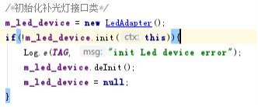

Anti-initialization:

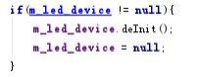

Hangzhou Leshun Information Technology Co., LTD

2.2 Screen backlight interface

Using the LedAdapter interface class (refer to 2.1 for initialization)
public int getScreenBrightness()-----Return to the current brightness of the screen, range: 0-255
public boolean setScreenBrightness(int level)-----Set the screen brightness, the parameter is the brightness value, range: 0-255, return whether the setting is successful or not
Note: The standard Android brightness method either sets the current Activity or requires user authorization; so package this interface to improve convenience and user experience.

2.3 Uart read-write interface

Using the SerialPortAdapter interface class, initializing the initial reference is as follows:
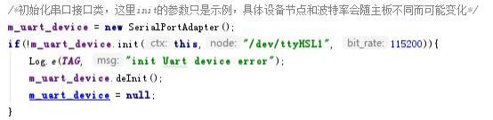
public boolean write(byte[] data, int len)
-----Serial output interface, with parameters for output data and length; Returns whether the serial output was successful.

public boolean startRead(HWDataCallBack cb)
-----Start serial port reading, parameter is callback interface, return success or failure

public void stopRead()
-----Stop serial port reading interface
Note: The node of serial ports and Bitrate may vary for different devices; LSP980 landscape consumer machine corresponds to the RS232 protocol Uart port of RJ 12 interface, serial port nodes: /dev/ttyHSL1, common Bitrates is supported. Line order definition of RJ 12 serial port:

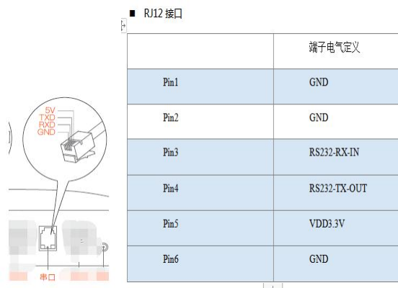

2.4 QR Scanner Interface

QR Scanner is serial port communication, refer to 2.3 serial port interface. Scan terminal corresponding serial port node: /dev/ttyHSL3, Bitrate 9600. Note: Do not handle too time-consuming operations in the callback interface.

2.5 NFC interface

Using NFCAdapter interface class to prevent multitask from calling NFC device, this interface class is singleton mode, initialized in the figure below:
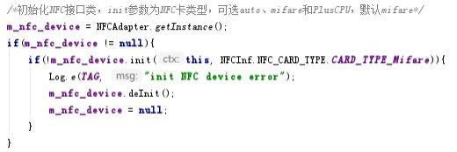

public boolean startRead(HWDataCallBack cb)
public boolean startRead(HWDataCallBack cb, boolean bsingle)
-----Start reading NFC data, the parameter is callback interface / prevent duplicate reading card (optional, default false), return success or not
-----Once the interface called, and only the data can be obtained once. After processing the data, according to the scene delay, please refer to the example code; besides, the data returned by NFC device is 16 decimal string (4 or 7 bytes, small tail), please convert as needed.
public void stopRead()
-----Stop the NFC read interface
Note: Due to the large number of NFC card reading devices and many types of cards, it only supports Mifare S50/70 type cards, PlusCPU cards and CPU cards at present. Other new cards will update documents and system firmware in time.
public int readBlock (int block_id, byte[] auth_key A, byte[] auth_key B, byte[] buffer_rx)
-----read the specified block

/* To read the specified block data, it should be called in the callback function set by the startRead interface (when the card number is received, the card is approaching), and the secret key A and B should be passed in in either way
* Parameter block_id: Block ID to be read, take the Mifare S50 card as an example, range 0-63, total
16 sectors, 4 blocks in each sector, and 16 bytes in each block; the last block in each sector (No.3、7、11......) Store the secret key-related
* Parameter auth_key A: Secret key A, 6 bytes or 16 bytes (PlusCPU SL3), can be NULL
* Parameter auth_key B: secret key B, 6 bytes or 16 bytes (PlusCPU SL3), can be NULL
* Parameter buffer_rx: Read data cache, one block size, 16 bytes
* Return value: length of data read, -1 indicates secret key error; -2 indicates other error */

Note: Secret key A and secret key B, either pass in, if both pass NULL, use default secret key A verification; read data is stored in buffer_rx array, refer to the example code for details.
public int writeBlock(int block_id, byte[] auth_keyA, byte[] Auth_key B, byte [] buffer_tx) -----writes to the specified block
/* Write the specified block data, it should be called in the callback function set by the startRead interface (when the card number is received, the card is approaching), and the secret key A and B should be passed in in either way
* Parameter block_id: block ID to be written, for example, Mifare S50 card, range 0-63, total
16 sectors, 4 blocks in each sector, and 16 bytes in each block; the last block in each sector (No.3、7、11......) Store the secret key-related

* Parameter auth_key A: Secret key A, 6 bytes or 16 bytes (PlusCPU SL3), can be NULL
* Parameter auth_key B: secret key B, 6 bytes or 16 bytes (PlusCPU SL3), can be NULL
* Parameter buffer_tx: data cache to be written, one block size, 16 bytes
* Return value: 0 indicates success; -1 indicates secret key error; -2 indicates other error */

public int sendAPDU (byte[] cmd, int cmd_len, byte[] buffer_rx)
/* The CPU card sends the APDU package
* Parameter cmd: APDU, command data
* Parameter cmd_len: the length of the cmd
* Parameter buffer_rx: returned the buffer of data, buffer length should not be less than the length of data returned by this command, otherwise data will be lost
* Return value: length of data read (greater than or equal to 0), negative number indicates command execution error */ Reference code:
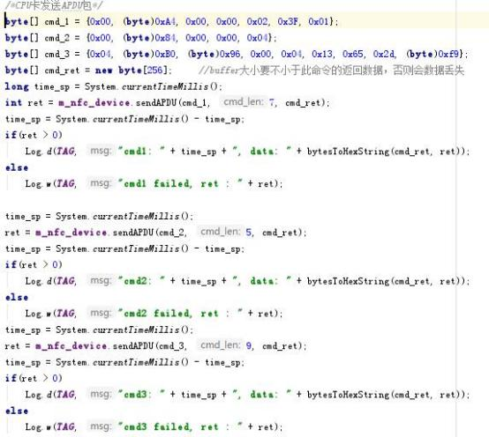
public int getATS(byte[] buffer_rx)
/ * CPU card acquisition of ATS (answer to select)
* Parameter buffer_rx: The returned data buffer area, the CPU card is generally 16 Byte, Plus CPU, and the card is generally 12 Byte
* Return value: Data length of ATS; negative number indicates error */ Reference code:
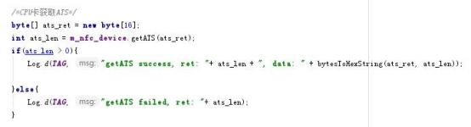

Hangzhou Leshun Information Technology Co., LTD

2.6 System information interface

Using the SystemAdapter interface class, since this interface involves IMEI reading, add READ_PHONE_STATE permission (After Android 6.0, dynamic permission application is required) and initialize the figure below:
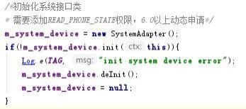
public float getCPUTemp()
-----Return to the current CPU temperature in degrees Celsius
public String getDeviceUniqueID()
-----Returns the unique identification number of the device, typical such as IMEI, SN, MAC address or its combination.

public boolean isEthernetOn()
-----Query the Ethernet switch.
public boolean setEthernetOn(boolean on)
-----Set the Ethernet switch, the parameter is whether on; since this operation is asynchronous, it is recommended to delay 1 second to query whether really on/off success.
public boolean isMobileDataOn ()
-----Query the data connection switch.

public boolean setMobileDataOn(boolean on)
-----Set the data connection switch, the parameter is whether on; because this operation is asynchronous, it is recommended to delay 1 second to query whether really on/off success; note: Network priority Ethernet > WIFI> data connection.
public String getEthernetMac()
-----Get Ethernet MAC, possibly return NULL
public String getWIFIMac()
-----Get the WIFI MAC, it is possible to return the NULL

2.7 Camera interface
LSP980 Model without camera, other models with camera in the same series will choose binocular USB camera, which can be accessed through Android standard Camera interface (IR light is controlled by IR camera, without operation).

2.8 Restart/timing restart
1) Using the SystemAdapter interface class, refer to 2.6 for initialization
public void reboot()
-----Restart the system interface
2) Regular restart, the implementation principle is to set the RTC clock through the AlarmManager, and do the restart action in the corresponding PendingIntent, for example:
am = (AlarmManager)context.getSystemService(Context.ALARM_SERVICE);
am.set (AlarmManager.RTC_WAKEUP, timestamp, pendingIntent );
Note: Since the timing boot function depends on rtc battery, and our machine is automatically powered up; we worry that if the timing switch function is used, the timing boot function fails, and the operation and maintenance personnel need to manually start on site. In order to avoid this situation, we do not recommend the timing switch function! We recommend using: regular restart (for the shipping machine, we default will configure every day at 5 am automatic restart, this can cancel, can be configured); App can also regularly call restart function, if you want to turn off the screen when not in use, can call the LedAdapter interface to close the screen, when needed to open the screen (if it is turned off or power off, the default brightness will be restored after restart). If you must use the timing switch, please contact the technical support for a separate nstructions.

2.9 Printer interface
Printer model EM5822, is a USB interface, HWAdapterTest reference code has the initialization process and simple printing test, need to join the printer support library printsdk.jar, reference code:

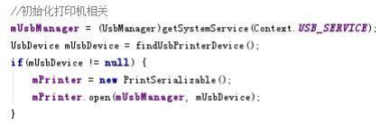

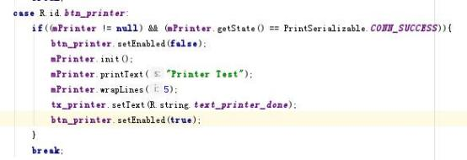

For more printing instructions (format), please refer to the printer data package provided by the supplier: EM5822_printer_data.rar

2.10 Hide the navigation bar and the status bar

1) This function can be implemented by setting window properties by Activity, as below:
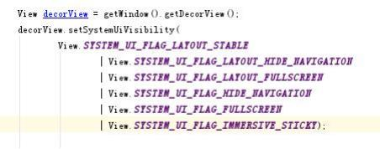

The effect is that in this Activity, the status bar and navigation bar are hidden, sliding from the edge, automatically hidden for seconds, and quitting the Activity is invalid.
- It can be realized through SystemAdapter interface (the navigation bar is hidden, the status bar is not sliding down), as follows:

The effect is that the navigation bar is hidden from the system, the swipe is not displayed and works for all Activity.
3) Query whether the navigation bar is displayed
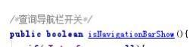

2.11, silent installation

The Apk silent installation function is mainly used for the App unattended self-upgrade, using the SystemAdapter silentInstall interface, defined as follows

identifying code:

2.12, dual-screen display

LSF980 Series landscape consumer machine, using the main 10 inch landscape screen + auxiliary 5 inch portrait screen display, dual screen display secondary screen content display in the center, App can do dual screen display, the secondary screen can be displayed in full screen. Dual screen display using the Google standard practice, using Presentation implementation, specific can refer to the online information.

3. Commissioning instructions

3.1 Install the APK

1) The U-disk installation method can be adopted. After inserting the U disk, enter the main interface, open the file manager, select the U disk (as shown in the figure below), find the APK to be installed, and install it directly.

Hangzhou Leshun Information Technology Co., LTD
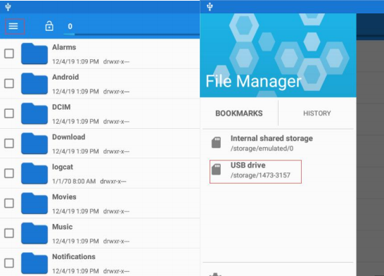
3）ADB installation method, refer to the adb debugging steps, and after connecting, use the adb install xxx.apk method to install。

3.2 adb debugging

1) Please connect to the network (wired or WIFI; the cable network supports DHCP and static IP) and ensure that the device IP is in the same network segment as the computer. Device IP can be viewed in the settings, as shown in the figure below:
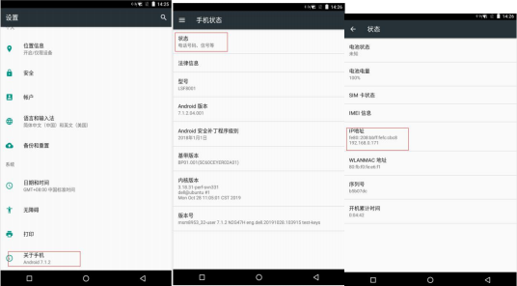

Hangzhou Leshun Information Technology Co., LTD
Then, in the command line, use adb connect ip: 8888, as shown below:
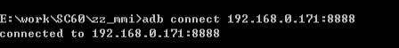
After the connected to ip appears, the adb debugging function can be used normally.
2) If the cable network needs to be configured as a static IP, please enter the Settings-> Ethernet, and then fill in the information related to the fixed IP and save it. Where Network prefix length refers to the length of the subnet mask. For example, 255.255.255.0 is the first the first 3 bytes as the mask, so fill in 24.
